Software Architecture Document
  - Initiative Name: SABL – Secure Access Boundary Layer
  - Author: Benjamin Soto-Roberts
  - Created: 07/16/2026

Introduction

1.1 Problem Statement/Value Proposition
SABL was initiated as a practice-portfolio project to better understand security and the SDLC. SABL is a simple, lightweight IAM component for secure access to a rest API that has multi-tenant support. The project will explore crucial security protocols for architecting and designing a secure API with a shift left approach to software development.

1.2 Goals and Constraints
- Implement a full SDLC with supporting documentation
- STRIDE Threat Model
- Create a secure pipeline to building and deploying – CI/CD out of scope
- HTTP Basic authentication over HTTPS/TLS
- Brute-force and rate-limit protections
- Structured Logs for Authn/Authz events
- Role-based access control (RBAC)
- Standardized http responses

1.3 Technology Stack
- Java 21
- Spring Framework
- Mkcert – Self signed cert/trusted ca
- Keytool – Secrets storage
- H2 Database/Postgresql
- Apache Maven
- Semgrep
- Sonarqube
- Bucket4j
- Caffeine
- Owasp Dependency-Check
- Jacoco

System Context & High-Level Design

2.1 System Component Map
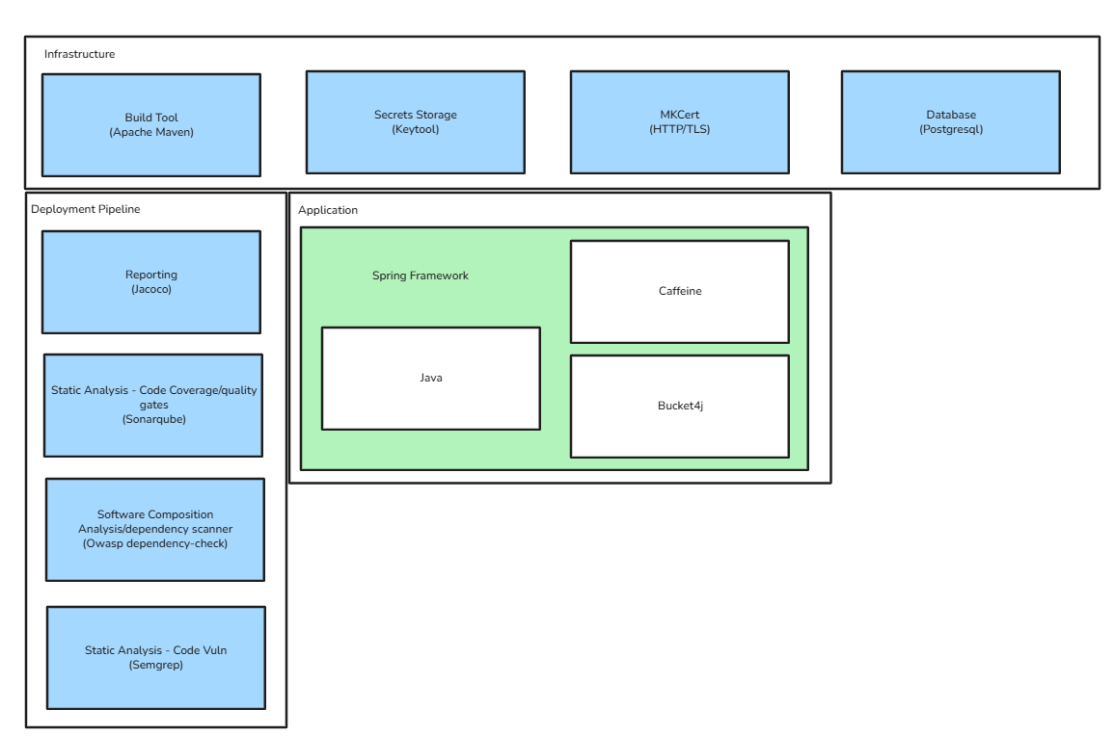

2.2 System Context Diagram
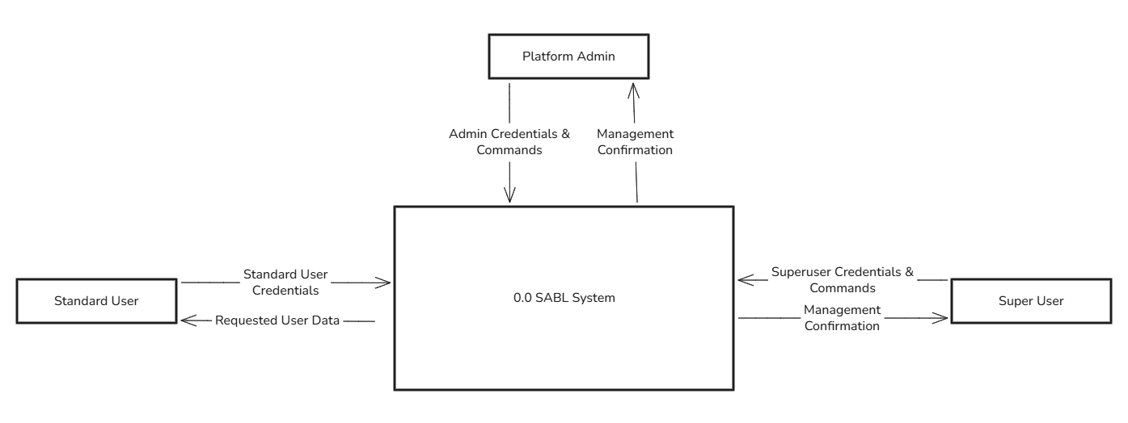

Component & Data Design

3.1 Container/Component Diagram
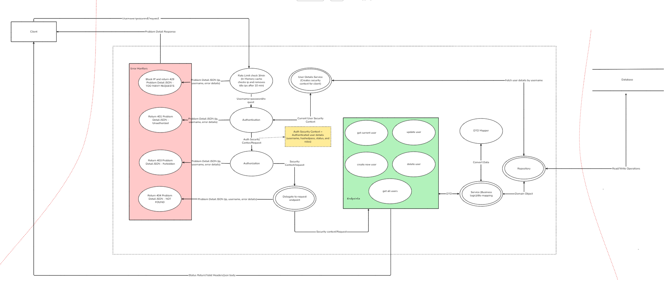
- Client sends request with http basic auth header including username and password and request body.
- Rate Limiting Filter intercepts request and checks IP/attempted username against in memory cache to limit requests by IP/Username to 3 per minute (for testing).
  - Returns 429 – TOO MANY REQUESTS problem detail response(RFC 9457) and resets after 60 seconds.
  - Log event as excess_rate_limit_exceeded (OWASP Logging Vocabulary).
  - Enforce Block/lock of ip/username after being rate limited X times?
- Authentication filter calls to a custom user details service that checks the database for user with attempted username and creates a security context for the user if the user exists. The user details service passes back the security context and attempts to authenticate the user or an exception propagates to the authentication filter which then signals a 401 response.
  - Returns 404 – UNAUTHORIZED problem detail response(RFC 9457).
  - Log event as authn_login_fail/authn_login_success (OWASP Logging Vocabulary).
  - Enforce lock of username after too many failed attempts within X timeframe?
- Authorization filter checks whether the already-authenticated user has the roles or permissions to access the requested endpoint.
  - Returns 403 – FORBIDDEN problem detail response(RFC 9457).
  - Log event as authz_fail/authz_admin for protected endpoints (OWASP Logging Vocabulary).
  - Enforce lock of username after too many failed attempts within X timeframe to a protected endpoint?
- A delegating request filter delegates the request to the specific endpoint if the endpoint exists.
  - Returns 404 – NOT_FOUND problem detail response(RFC 9457).
- Controller endpoint for GET current user only requires the user be authenticated and is not locked down by a specific role.
  - GET current user returns the current authenticated user’s non sensitive user data. {username:XXX, orgName:XXX, status:XXX, roles:[XXX,XXX]}with 200 OK status code.
- Controller endpoint for GET all users requires an elevated user role either platform admin or super user.
  - Platform admin returns all user data regardless of organization as standard json response with 200 OK status code.
  - Super user returns only all user data associated with the super user’s organization s standard json response with 200 OK status code.
  - Event log associated with 4.b as stated above.
- Controller endpoint for POST create new user requires an elevated user role either platform admin or super user.
  - Platform admin can create any user regardless of organization or role and returns response with 201 CREATED status code and the URI of the new resource.
  - Super user can create only standard users and only for the associated organization. Returns response with 201 CREATED status code and the URI of the new resource.
  - Event log associated with 4.b as stated above.
- Controller endpoint for PUT update user requires an elevated user role either platform admin or super user.
  - Platform admin can update any user regardless of organization or role and returns response with 200 OK status code and the updated resource.
  - Super user can update only standard users and only for the associated organization. Returns response with 200 OK status code and the updated resource.
  - Event log associated with 4.b as stated above.
- Controller endpoint for DELETE delete user requires an elevated user role either platform admin or super user.
  - Platform admin can delete any user regardless of organization or role and returns response with 200 OK status code and the updated resource in response body.
  - Super user can delete only standard users and only for the associated organization. Returns response with 200 OK status code and the updated resource.
  - Event log associated with 4.b as stated above.
- The request from the controller is ran through the service layer where dto mapping and business logic is applied and then sent to the data layer (repository) for querying.
  - Request from controller is mapped from requestDto to an app user domain model and then queried from the repository.
  - A response is mapped from a domain gathered from the repository and then sent back up to the controller layer.
  - Plan for bad requests/malformed json….

3.2 Data Flow
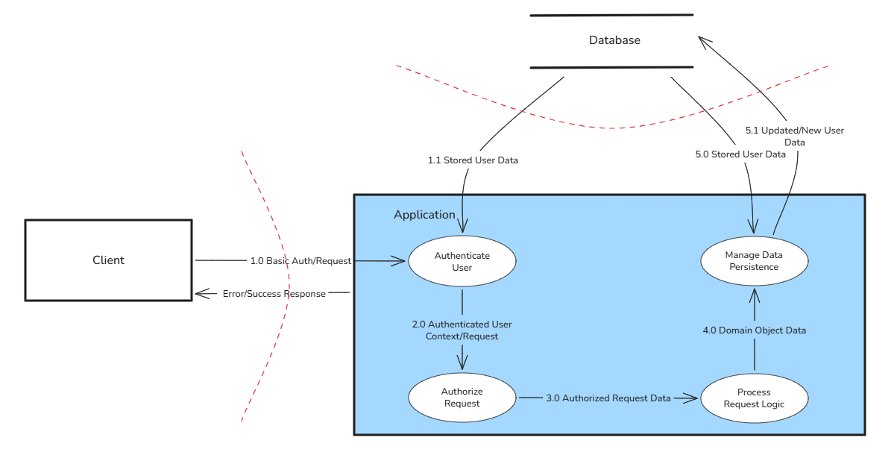

3.3 Database Schema
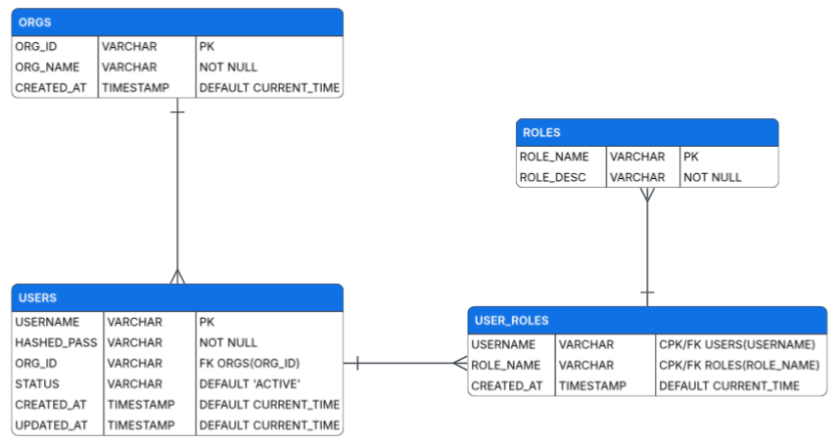

Non-Functional Requirements (NFRs)

4.1 Security & Compliance

4.2 Performance & Scalability

Implementation & Risks

Deployment Strategy
Phase 1: Walking Skeleton
- Deploy a single endpoint and test
Phase 2: Enable Security
- Deploy Authn/Authz service and test
Phase 3: Standardize Problem Detail Responses
- Standardize problem detail responses on 401, 403, and 404
  - Reference RFC {9457, }
Phase 4: Enable Rate Limiter
- Deploy rate limiter and standardized 429 problem detail response and test
Phase 5: Structured Logging on Auth events
- Deploy Structured json logging for authn and authz events
  - Reference Logging Vocabulary - OWASP Cheat Sheet Series
Phase 6: Endpoints
- Deploy client facing controller endpoints and logic and test
Phase 7: End 2 End testing
- API tests E2E – validate functionality
- PenTest – validate security controls
Out of scope: Log ingestion/seim
In Scope: log directory storage with rotation

5.2 Trade-offs & Alternatives
ADR-01. In memory database for practice project. – H2
- Simple implementation
- Not production grade
ADR-02. In memory rate limiting, no redis or distributed cache. – Bucket4J/Caffeine
- Simple implementation
- Needs to manage memory consumption
ADR-03. JdbcTemplate, no ORM
ADR-04. Shared Database, shared schema
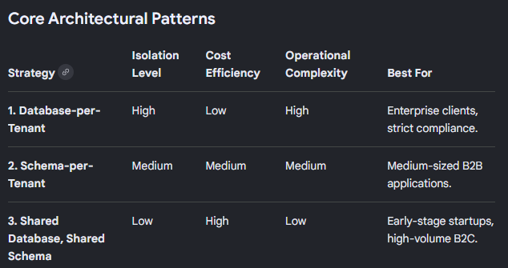
ADR-05. Functional RBAC vs RBAC Hierarchy
ADR-06. Http basic authentication with enforced https/tls – Mkcert for local development
- No JWT, Sessions, or 0auth2.0
ADR-07. Org self service is managed by org super user. Org super users are managed by platform admins as requested by the organization.
- No self service registration.
- Privileged users must register lower level users

